E. V. Gray Historical Series

Starting with the Start Motor Mark McKay, PE

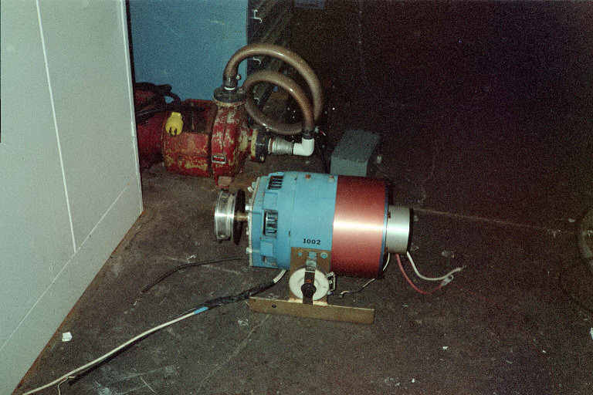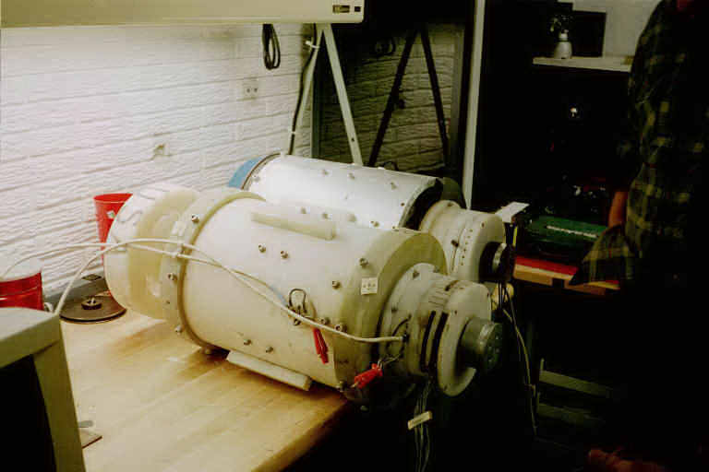
. The Start Motor as Found in 2000 EMA4 and EMA5 Motors as Found in 2000

E. V. Gray once commented to John Bedini that his early free energy experiments were conducted with modified off the shelf industrial motors. It is assumed that when Mr. Gray’s finally got adequate funding he went on to build a series of custom made motors that could take better advantage of the unique properties of his non-classical “Cold Electricity”. These experimental designs were stamped with the model numbers EMA1 through EMA6. The EMA4-E2 and the EMA6 are his most well know constructions and are always associated with Mr. Gray’s work. However, there were other transitional models built.

There may be one recovered example of a pre-EMA series motor that might have served as a functional test bed and very possibly an early investor demonstration model (circa 1963 to 1969).

In 2000 friends of Norm Wooten discovered two original EV Gray motors in a shop somewhere in Texas (most likely Grande Prairie, Texas where Mr. Gray had established a shop in 1986). These were the EMA4 and the EMA5 prototypes. Mr. Wooten acquired these pieces of history from the building land lord. He then took them to his shop where they were carefully disassembled. Later he produced a highly recommended video of his observations for the 2001 Keely conference in Florida. This informative tape is available from Clear-Tech at http://www.free-energy.cc/index.html in DVD and VHS formats. At the time the “Start Motor” was considered insignificant and therefore not looked at very closely.

After considerable mechanical analysis of the EMA4 and EMA5, Mr. Wooten came to the conclusion that this equipment contained no obvious free energy secrets. The vital energy converters that had powered these unique motors were not found. A few years later he decided to sell this collection.
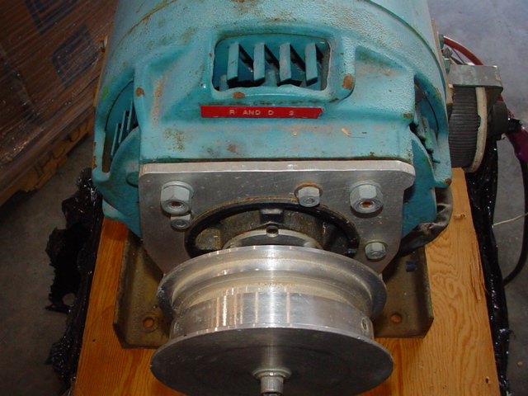
Mr. Allan Francoeur of Penticton, BC, a long time free energy researcher and inventor, bought the entire lot for $5,000 US in 2003. This package included the two prototype evaluation motors (EMA4 and EMA5), one of Mr. Gray’s advanced coil popping setups (partial), and an 1940’s modified non descript industrial motor. It was assumed, at the time, that this humble looking machine was a high voltage (5KV) generator used by Mr. Gray to charge up his storage capacitors for motor experiments. Later it was proposed that it was a DC motor used to start up Mr. Gray’s large experimental motors, thus it finally became known as simply the “Start Motor”. The Start Motor could also have been thought to be a dyno-motor. In this capacity it could have acted as a dynamic load to evaluate the performance of Mr. Gray’s energy converters.

For a number of reasons this author contends that this piece of equipment was an actual working EV Gray pulse motor prior to the construction of the custom EMA models.
. Custom Adapter Flange Added to Front of Motor

Showmanship Tells All

Mr. Gray spent some serious money to have this simple motor dressed up way beyond any practical bench top need. If he wanted to conceal the details of its internal wiring from the occasional investor visit, then some heavy gauge sheet metal would have been a cost effective solution. Yet, this “Start Motor” was outfitted with a custom built three piece three color (Red, White, and Blue) anodized aluminum cowling set. The large red section was outfitted with a dozen small machined ventilation slots. These three pieces of non-functional eye candy probably cost him 50 times what the motor was worth, but may have been thought important enough, at the time, to help advance his early business development efforts.

As it turns out, the Start Motor is not a motor but a 5 KW DC exciter generator, circa 1940, used to provide field coil power for a larger generator (75KW to 150 KW). The 4-pole salient stator is outfitted with dual field coils that function in a compound wound configuration. It also has an independent set of slip rings that are connected to the armature coils and thus allow for external regulation. It looks odd, when compared to modern generators, because it has a commutator, like a DC motor, plus two additional slip rings like an AC motor. With the advent of solid state power rectifiers the slip rings and commutator bars in small generators have been completely eliminated, so you seldom (if ever) see this kind of construction. Externally mounted exciters have also been eliminated from the larger generator sets as well for much the same reasons. This same design was also called a “Three Wire Generator”. These were used in the 20’s to provide unbalanced three wire DC power for combination motor and lighting loads.

Modification Details

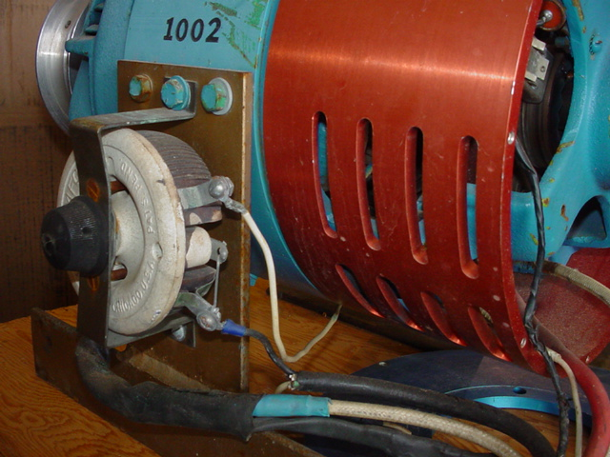
Mr. Gray did a custom retro-fit to the front end of this motor. This modification was intended to be an adapter plate that would allow different flange mounted gear boxes to be attached. He also installed a simple magnetic probe in between two of the stator coils. The Start Motor was also reconfigured to receive its power through a #4 AWG cable (see the discussion about the cable used for the EMA4). There is a 2 Ohm 100 watt rheostat attached to the Start Motor’s side that has one #14 AWG cable going to one slip ring and the other going elsewhere (not connected). The return large red cable (ground?) was connected directly to the generator frame once it got inside the case. Having prime power travel through the frame of a generator or motor is defiantly not a traditional electrical practice. Except for the rewiring of the stator coils, the probe, and the cowling the rest of the motor appears to be “stock”. There were two suppressor capacitors associated with the slip rings that are similar to 50’s automotive distributor condensers. These seemed to be original equipment and had not been replaced. One of the slip ring brushes appears to have been replaced once.
. Side Mounted 200 Watt 2 Ohm Rheostat and Attached Cabling
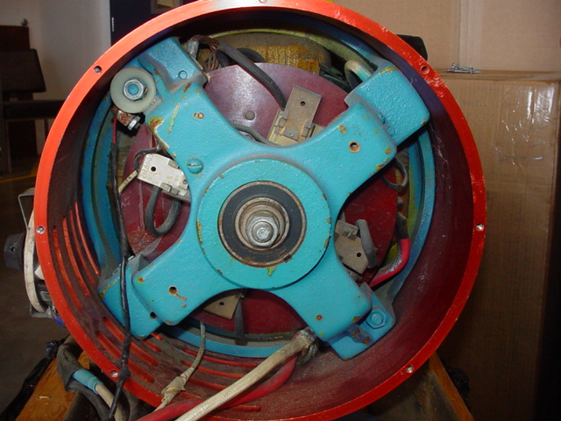
The recovery and simple analysis of the Start Motor only reinforces what has already been suspected about Mr. Gray’s technology:

1.) There is no obvious over-unity process to be found in this rotary converter. (But that doesn’t mean there are none)

2.) This device was designed to have all the stator and rotor coils pulsed at once. This is an operational feature that appears common in Mr. Gray’s motor systems.

3.) Applied Voltage considerations: The effective classical voltage potential of the energy that passed through this device certainly did not exceed 600 volts and most likely did not get beyond 300 volts. Had Mr. Gray exceeded these parameters, given the age of these exciter generators windings, he would have risked an insulation failure. The typical classical operation of an exciter generator like this was typically 120 VDC at 50 Amps.

. Back End View of the “Start Motor”
Interesting Thoughts:

Why was Mr. Gray still hanging on to this early prototype demonstration motor (for some 15 years) in the first place? Technically, it would appear that it was a relic from his development past, when compared to the advanced EMA4 and EMA5 evaluation motors. He certainly paid good money to have this equipment shipped from his Van Nuys, CA shop to Texas, so it must have been of some value. The “Start Motor” weighs about 75 lbs. The best speculation to date is that Mr. Gray was probably saving his more important milestone pieces of equipment for a future exhibit in some national technical museum. If this is partially true then the importance of the “Start Motor” should not be over looked.

The schematic for the “Start Motor” below is the author’s best attempt, with out disassembling the motor completely, to show the modified internal wiring.
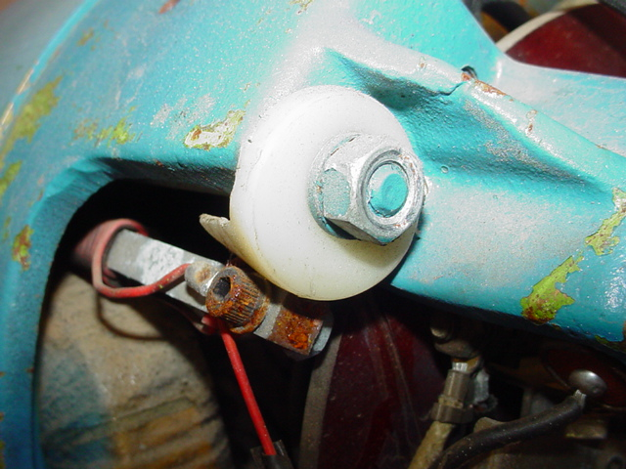

Al Francoeur has taken very good care of this earliest surviving example of Mr. Gray’s technology. It has been repaired, lubricated, cleaned up and now sports a new paint job. All that is needed is a reproduction EV Gray pulse energy converter to bring the “Start Motor” back to life.

If a breakthrough is ever re-discovered that unlocks the secrets of the methods used to create “Cold Electricity” then this modified exciter motor could well end up as a featured exhibit in the Smithsonian. This could have been what Mr. Gray intended all along.

. Added Magnetic Probe Next to Stator Winding
. Assumed Used for Positional Feedback

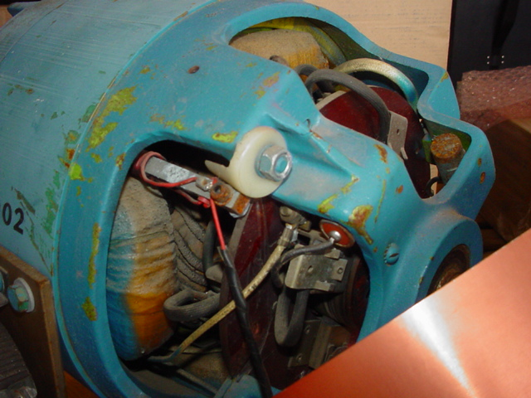
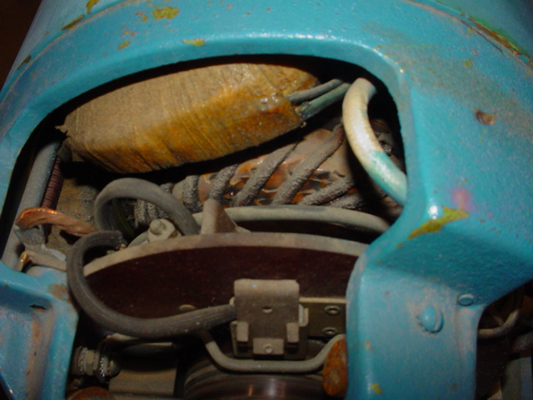
. Backend of the “Start Motor” View of Compound Stator Coil and Slip Rings

